Rusty Coonfield Resume of Qualifications
843 Cypress Pkwy #152
Kissimmee, FL 34759
559.303.0339
rusty@coonfield.net
www.coonfield.net

FLIGHT TIME:
Total Time 764.2
Pilot-in-Command | 677.3 | Turbojet | 9.8
Instructor | 40.6 | Multi-Engine | 57.4
Tailwheel | 464 | Cross Country | 369.3
Turbine | 3.8 | Actual Instrument | 10.7

CERTIFICATIONS:
Certificate: Commercial Pilot, Instrument & Multi-Engine
Certified Flight Instructor, SEL
Medical: Class Two

EMPLOYMENT HISTORY:
Forestry Technician  (Firefighter)  04/00-4/05 | U.S. Dept. Interior - Park Service, Sequoia National Park, CA  helicopter crewmember, crew leader, incident commander type 5,  GPS and computer aerial mapping, structural & wildland firefighter, interagency  aviation trainer, multimedia presentation & management, helicopter search & rescue
Aircraft Line Service Technician  11/99 – 12/99 | Columbia Gorge Regional/The Dalles Municipal Airport, The Dalles, OR  aircraft fueling, customer service, aircraft maintenance assistant, cashier
Forestry Technician  (Firefighter)  9/99-11/99 | U.S. Dept. Agriculture - Forest Service, Mt. Hood National Forest, OR  wildland firefighter, fire engine crewmember, crew motivation, chainsaw work
Digital photographic & imaging specialist  Self Employed  1991-9/99 | Clients:  The Morning News of Northwest Arkansas  Colormate Photo of Northwest Arkansas  Process One Photo of Northwest Arkansas  Berquist & Associates photography, Fayetteville, AR  Digital photographic acquisition and manipulation, Web & Graphic Design, Digital image asset management, equipment & Software management

EDUCATION:
Bachelor of Arts Degree, 2000. University of Arkansas, Fayetteville, AR
Major: Fine Arts with emphasis in Graphic Design.

PERSONAL DATA:
Date of Birth: 03/29/1973 | Health: Excellent (Non-Smoker)
Height: 5'10" | Marital Status: Married
Weight: 165 | Availability: Immediate

Rusty Coonfield
843 Cypress Pkwy #152, Kissimmee, FL 34759 ♦ Home/Mobile: 559.303.0339

Dear Sir or Madam:

Greetings. Enclosed please find a copy of my resume listing my qualifications for becoming a pilot for your company. I would be an asset by providing excellent customer relations skills and a diverse background in aviation and flight experience. My goal is to advance my aviation career while providing excellent service.

I look forward to the occasion where we can discuss my qualifications for a position in more detail. I am available for an interview with you at your earliest convenience. If you have any questions, please feel free to contact me. Thank you for your consideration.

Sincerely,
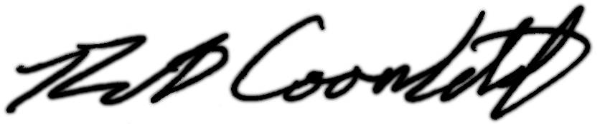

Rusty Coonfield

Resume enclosed

